**FINOLEX ACADEMY OF MANAGEMENT AND TECHNOLOGY, RATNAGIRI**

**DEPARTMENT OF MCA**

**PRACTICAL NO. 05**

**Web Services and WCF**

1. **Create an XML Web Service to implement calculator with web methods to add, sub, multiply, divide two decimal values. Consume this service through a web client application.**

**Ans:**

1. **Project 1 - XMLWebService_Calculator**

* **CODE –**

**WebService_Calculator.asmx.cs**

using System;

using System.Collections.Generic;

using System.Linq;

using System.Web;

using System.Web.Services;

namespace XMLWebService_Calculator

{

/// <summary>

/// Summary description for WebService_Calculator

/// </summary>

[WebService(Namespace = "http://tempuri.org/")]

[WebServiceBinding(ConformsTo = WsiProfiles.BasicProfile1_1)]

[System.ComponentModel.ToolboxItem(false)]

// To allow this Web Service to be called from script, using ASP.NET AJAX, uncomment the following line.

// [System.Web.Script.Services.ScriptService]

public class WebService_Calculator : System.Web.Services.WebService

{

[WebMethod]

public decimal add(decimal a, decimal b)

{

return a + b;

}

[WebMethod]

public decimal sub(decimal a, decimal b)

{

return a - b;

}

[WebMethod]

public decimal mul(decimal a, decimal b)

{

return a * b;

}

[WebMethod]

public decimal div(decimal a, decimal b)

{

return a / b;

}

}

}

* **OUTPUT-**

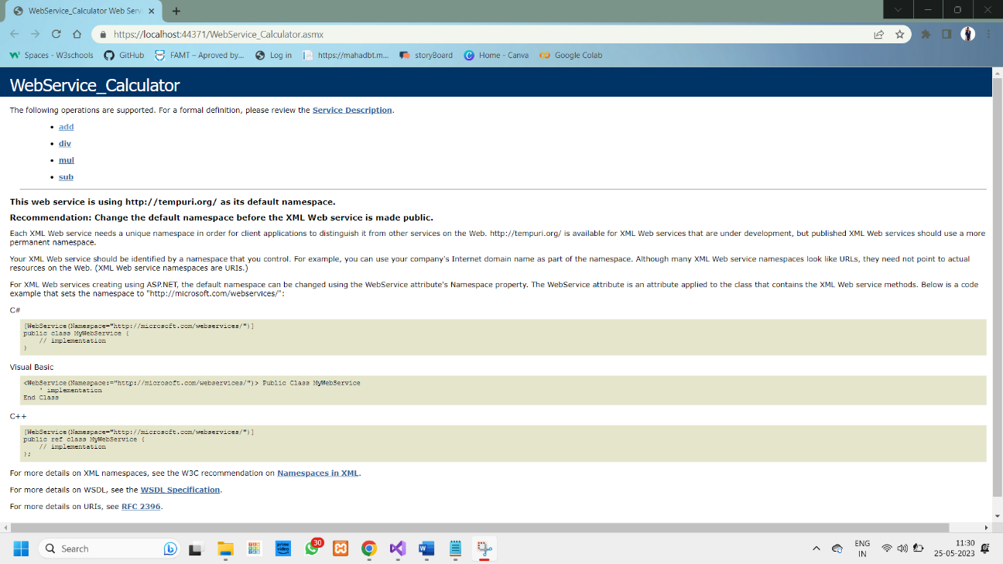

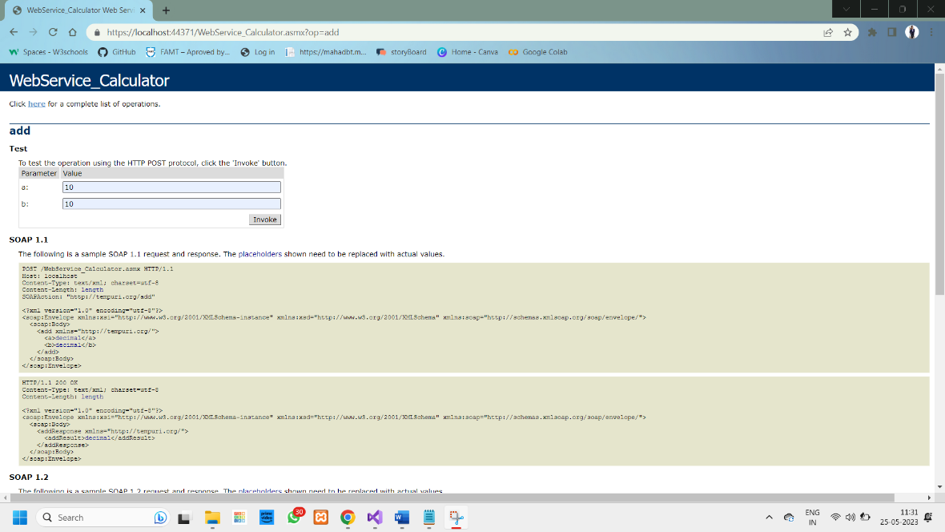

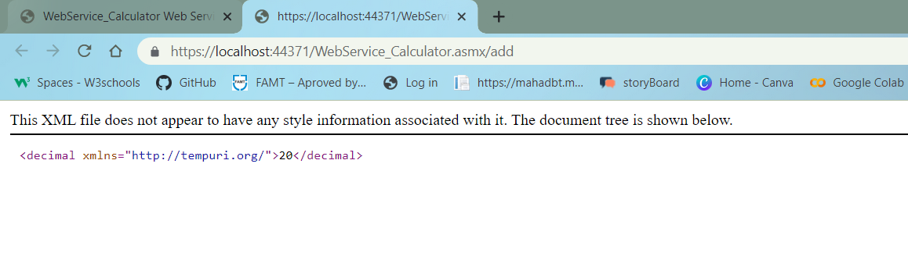

**2)Project 2 - XMLWebService_Calculator_Client**

* **CODE –**

**WF_Calculator.aspx**

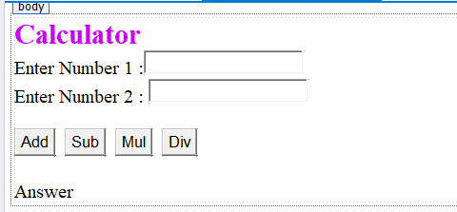

<%@ Page Language="C#" AutoEventWireup="true" CodeBehind="WF_Calculator.aspx.cs" Inherits="XMLWebService_Calculator_Client.WF_Calculator" %>

<!DOCTYPE html>

<html xmlns="http://www.w3.org/1999/xhtml">

<head runat="server">

<title></title>

</head>

<body>

<form id="form1" runat="server">

<div>

<asp:Label ID="Label1" runat="server" Font-Bold="True" Font-Size="X-Large" ForeColor="#CC00FF" Text="Calculator"></asp:Label>

<br />

<asp:Label ID="Label2" runat="server" Text="Enter Number 1 :"></asp:Label>

<asp:TextBox ID="txtNum1" runat="server"></asp:TextBox>

<br />

<asp:Label ID="Label3" runat="server" Text="Enter Number 2 : "></asp:Label>

<asp:TextBox ID="txtNum2" runat="server"></asp:TextBox>

<br />

<br />

<asp:Button ID="btnAdd" runat="server" OnClick="btnAdd_Click" Text="Add" />

&nbsp;

<asp:Button ID="btnSub" runat="server" OnClick="btnSub_Click" Text="Sub" />

&nbsp;

<asp:Button ID="btnMul" runat="server" OnClick="btnMul_Click" Text="Mul" />

&nbsp;

<asp:Button ID="btnDiv" runat="server" OnClick="btnDiv_Click" Text="Div" />

<br />

<br />

<asp:Label ID="lblAnswer" runat="server" Text="Answer"></asp:Label>

</div>

</form>

</body>

</html>

**WF_Calculator.aspx.cs**

using System;

using System.Collections.Generic;

using System.Linq;

using System.Web;

using System.Web.UI;

using System.Web.UI.WebControls;

namespace XMLWebService_Calculator_Client

{

public partial class WF_Calculator : System.Web.UI.Page

{

ServiceReference1.WebService_CalculatorSoapClient proxy1 = new ServiceReference1.WebService_CalculatorSoapClient();

protected void Page_Load(object sender, EventArgs e)

{

}

protected void btnAdd_Click(object sender, EventArgs e)

{

decimal num1 = Convert.ToDecimal(txtNum1.Text);

decimal num2 = Convert.ToDecimal(txtNum2.Text);

lblAnswer.Text = proxy1.add(num1, num2).ToString();

}

protected void btnSub_Click(object sender, EventArgs e)

{

decimal num1 = Convert.ToDecimal(txtNum1.Text);

decimal num2 = Convert.ToDecimal(txtNum2.Text);

lblAnswer.Text = proxy1.sub(num1, num2).ToString();

}

protected void btnMul_Click(object sender, EventArgs e)

{

decimal num1 = Convert.ToDecimal(txtNum1.Text);

decimal num2 = Convert.ToDecimal(txtNum2.Text);

lblAnswer.Text = proxy1.mul(num1, num2).ToString();

}

protected void btnDiv_Click(object sender, EventArgs e)

{

decimal num1 = Convert.ToDecimal(txtNum1.Text);

decimal num2 = Convert.ToDecimal(txtNum2.Text);

lblAnswer.Text = proxy1.div(num1, num2).ToString();

}

}

}

* **OUTPUT-**

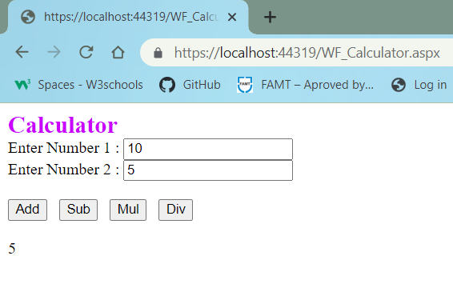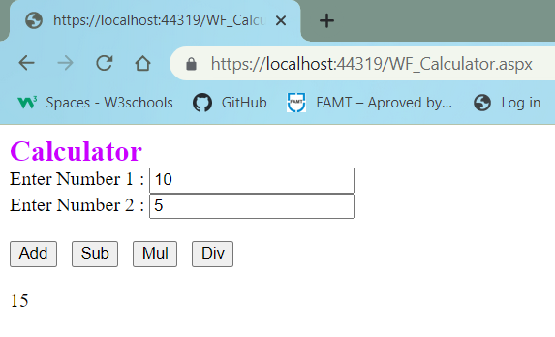

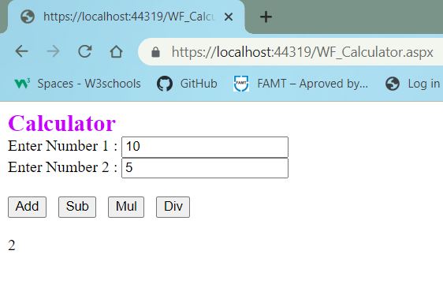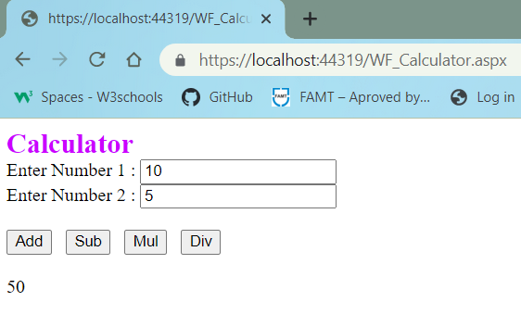

**2. Create an XML Web Service that retrieves employee details from emp_info Database table. Design a Web client that consumes this service.**

**Ans:**

* **Code-**

**WebServiceEmp.asmx:**

using System;

using System.Collections.Generic;

using System.Configuration;

using System.Data;

using System.Data.SqlClient;

using System.Linq;

using System.Web;

using System.Web.Services;

namespace XMLWebService_Emp

{

/// <summary>

/// Summary description for WebServiceEmp

/// </summary>

[WebService(Namespace = "http://tempuri.org/")]

[WebServiceBinding(ConformsTo = WsiProfiles.BasicProfile1_1)]

[System.ComponentModel.ToolboxItem(false)]

// To allow this Web Service to be called from script, using ASP.NET AJAX, uncomment the following line.

// [System.Web.Script.Services.ScriptService]

public class WebServiceEmp : System.Web.Services.WebService

{

static string conStr = ConfigurationManager.ConnectionStrings["ConnectionString"].ToString();

SqlConnection con = new SqlConnection(conStr);

SqlCommand cmd = null;

SqlDataReader dr = null;

DataTable dt = null;

[WebMethod]

public DataSet GetData()

{

cmd = new SqlCommand("SELECT * FROM emp", con);

if (con.State == ConnectionState.Closed)

{

con.Open();

}

cmd.ExecuteNonQuery();

SqlDataAdapter sda = new SqlDataAdapter(cmd);

DataSet ds = new DataSet();

sda.Fill(ds);

con.Close();

return ds;

}

}

}

**WebFormEmp.aspx:**

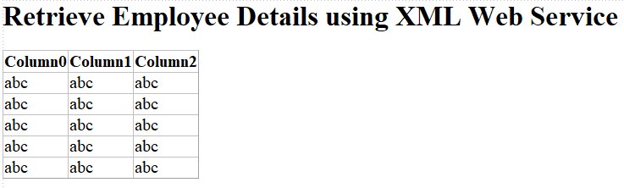

<%@ Page Language="C#" AutoEventWireup="true" CodeBehind="WebFormEmp.aspx.cs" Inherits="XMLWebServiceEmp_Client.WebFormEmp" %>

<!DOCTYPE html>

<html xmlns="http://www.w3.org/1999/xhtml">

<head runat="server">

<title></title>

</head>

<body>

<form id="form1" runat="server">

<asp:Label ID="Label1" runat="server" Font-Bold="True" Font-Size="20pt" Text="Retrieve Employee Details using XML Web Service"></asp:Label>

<br />

<asp:GridView ID="GridView1" runat="server">

</asp:GridView>

<br />

</form>

</body>

</html>

**WebFormEmp.aspx.cs:**

using System;

using System.Collections.Generic;

using System.Data;

using System.Linq;

using System.Web;

using System.Web.UI;

using System.Web.UI.WebControls;

namespace XMLWebServiceEmp_Client

{

public partial class WebFormEmp : System.Web.UI.Page

{

ServiceReference1.WebServiceEmpSoapClient proxy = new ServiceReference1.WebServiceEmpSoapClient();

protected void Page_Load(object sender, EventArgs e)

{

DataSet ds = proxy.GetData();

GridView1.DataSource = ds.Tables[0]; GridView1.DataBind();

}

}

}

* **Output:**



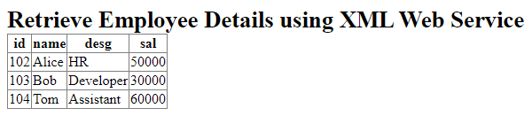

**3. Create an XML Web Service that insert employee details into emp_info Database table. Design a Web client that consumes this service.**

**Ans:**

* **CODE –**

**WebServiceEmp.asmx:**

using System;

using System.Collections.Generic;

using System.Configuration;

using System.Data;

using System.Data.SqlClient;

using System.Linq;

using System.Web;

using System.Web.Services;

namespace XMLWebService_Emp

{

/// <summary>

/// Summary description for WebServiceEmp

/// </summary>

[WebService(Namespace = "http://tempuri.org/")]

[WebServiceBinding(ConformsTo = WsiProfiles.BasicProfile1_1)]

[System.ComponentModel.ToolboxItem(false)]

// To allow this Web Service to be called from script, using ASP.NET AJAX, uncomment the following line.

// [System.Web.Script.Services.ScriptService]

public class WebServiceEmp : System.Web.Services.WebService

{

static string conStr = ConfigurationManager.ConnectionStrings["ConnectionString"].ToString();

SqlConnection con = new SqlConnection(conStr);

SqlCommand cmd = null;

SqlDataReader dr = null;

DataTable dt = null;

[WebMethod]

public DataSet GetData()

{

cmd = new SqlCommand("SELECT * FROM emp", con);

if (con.State == ConnectionState.Closed)

{

con.Open();

}

cmd.ExecuteNonQuery();

SqlDataAdapter sda = new SqlDataAdapter(cmd);

DataSet ds = new DataSet();

sda.Fill(ds);

con.Close();

return ds;

}

[WebMethod]

public int InsertData(int id, string name, string desg, int sal)

{

if (con.State == ConnectionState.Closed)

{

con.Open();

}

cmd = new SqlCommand("INSERT INTO emp(id, name, desg, sal) VALUES(@id,@name,@desg,@sal)", con);

cmd.Parameters.AddWithValue("@id", id);

cmd.Parameters.AddWithValue("@name", name);

cmd.Parameters.AddWithValue("@desg", desg);

cmd.Parameters.AddWithValue("@sal", sal);

int r = cmd.ExecuteNonQuery();

con.Close();

return r;

}

}

}

**WebFormEmp.aspx:**

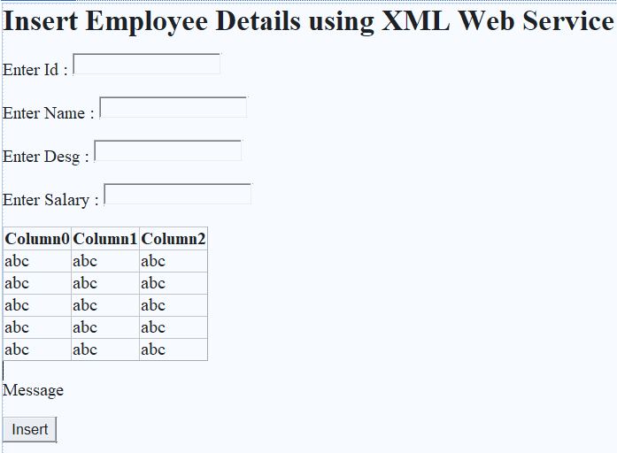

<%@ Page Language="C#" AutoEventWireup="true" CodeBehind="WebFormEmp.aspx.cs" Inherits="XMLWebServiceEmp_Client.WebFormEmp" %>

<!DOCTYPE html>

<html xmlns="http://www.w3.org/1999/xhtml">

<head runat="server">

<title></title>

</head>

<body>

<form id="form1" runat="server">

<asp:Label ID="Label1" runat="server" Font-Bold="True" Font-Size="20pt" Text="Insert Employee Details using XML Web Service"></asp:Label>

<p>

Enter Id :

<asp:TextBox ID="txtId" runat="server"></asp:TextBox>

</p>

<p>

Enter Name : <asp:TextBox ID="txtName" runat="server"></asp:TextBox>

</p>

<p>

Enter Desg :

<asp:TextBox ID="txtDesg" runat="server"></asp:TextBox>

</p>

<p>

Enter Salary :

<asp:TextBox ID="txtSal" runat="server"></asp:TextBox>

</p>

<asp:GridView ID="GridView1" runat="server">

</asp:GridView>

<br />

<asp:Label ID="lblMessage" runat="server" Text="Message"></asp:Label>

<p>

<asp:Button ID="btnInsert" runat="server" OnClick="btnInsert_Click" Text="Insert" />

</p>

</form>

</body>

</html>

WebFormEmp.aspx.cs:  
using System;

using System.Collections.Generic;

using System.Data;

using System.Linq;

using System.Web;

using System.Web.UI;

using System.Web.UI.WebControls;

namespace XMLWebServiceEmp_Client

{

public partial class WebFormEmp : System.Web.UI.Page

{

ServiceReference1.WebServiceEmpSoapClient proxy = new ServiceReference1.WebServiceEmpSoapClient();

protected void Page_Load(object sender, EventArgs e)

{

DataSet ds = proxy.GetData();

GridView1.DataSource = ds.Tables[0]; GridView1.DataBind();

}

protected void btnInsert_Click(object sender, EventArgs e)

{

int r = proxy.InsertData(Convert.ToInt32(txtId.Text), txtName.Text, txtDesg.Text, Convert.ToInt32(txtSal.Text));

if (r > 0)

{

txtId.Text = txtName.Text = txtDesg.Text = txtSal.Text = " ";

lblMessage.Text = "Record Inserted Sucessfully";

}

else

{

lblMessage.Text = "Record Not Inserted";

}

DataSet ds = proxy.GetData();

GridView1.DataSource = ds.Tables[0];

GridView1.DataBind();

}

}

}

* **Output:**

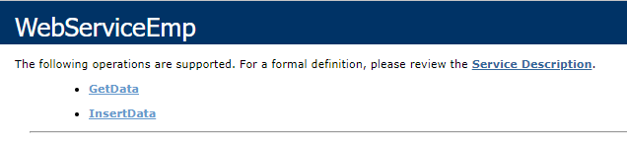

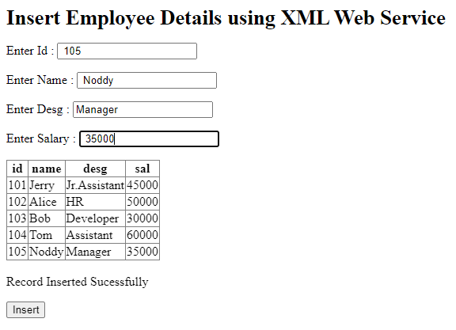

**4. Design a Web Service using WCF for simple Calculator and consume it with client application.**

**Ans:**

* **CODE –**

**1)Project 1 – WcfServiceLibrary_Calculator**

**Calculator_WCF.cs(Class File)**

using System;

using System.Collections.Generic;

using System.Linq;

using System.Runtime.Serialization;

using System.Text;

using System.Threading.Tasks;

namespace WcfServiceLibrary_Calculator

{

class Calculator_WCF

{

[DataMember]

public double n1;

[DataMember]

public double n2;

}

}

**ICalculator(Interface file)**

using System;

using System.Collections.Generic;

using System.Linq;

using System.Runtime.Serialization;

using System.ServiceModel;

using System.Text;

namespace WcfServiceLibrary_Calculator

{

[ServiceContract]

public interface ICalculator

{

[OperationContract]

double Add(double n1, double n2);

[OperationContract]

double Subtract(double n1, double n2);

[OperationContract]

double Multiply(double n1, double n2);

[OperationContract]

double Divide(double n1, double n2);

}

}

**ServiceCal(Service File)**

using System;

using System.Collections.Generic;

using System.Linq;

using System.Runtime.Serialization;

using System.ServiceModel;

using System.Text;

namespace WcfServiceLibrary_Calculator

{

// NOTE: You can use the "Rename" command on the "Refactor" menu to change the class name "Service1" in both code and config file together.

public class ServiceCal : ICalculator

{

public double Add(double n1, double n2)

{

return n1 + n2;

}

public double Subtract(double n1, double n2)

{

return n1 - n2;

}

public double Multiply(double n1, double n2)

{

return n1 * n2;

}

public double Divide(double n1, double n2)

{

return n1 / n2;

}

}

}

* **OUTPUT-**

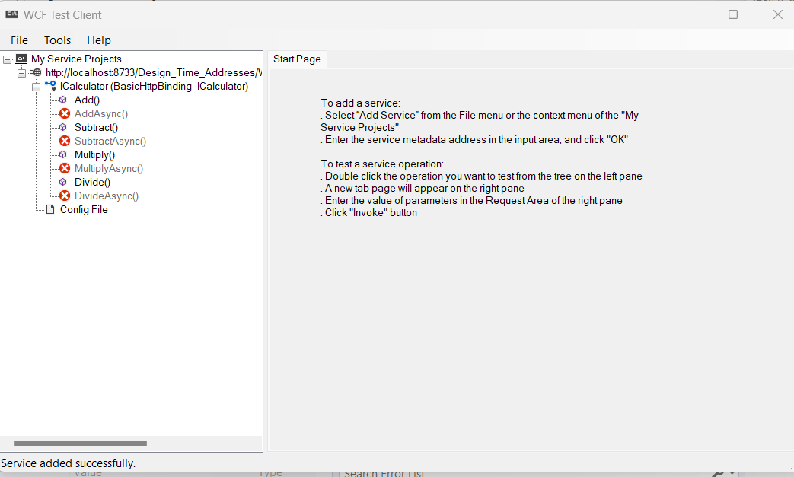

**2)Project 2-** **WcfServiceLibrary_Calculator_Client**

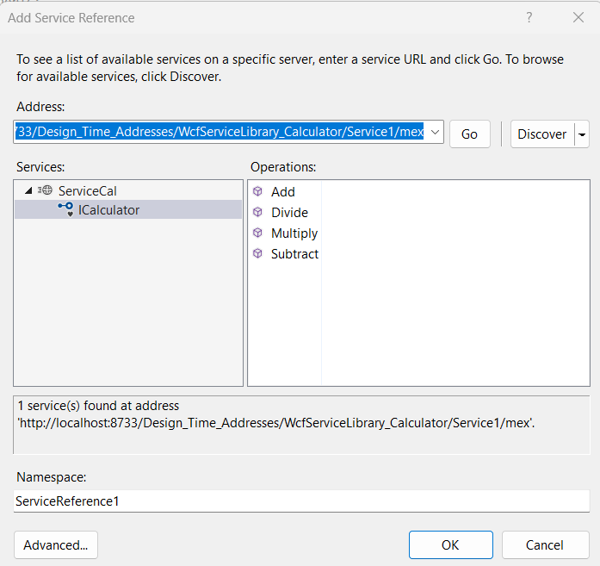

**WF_Calculator_WCF.aspx**

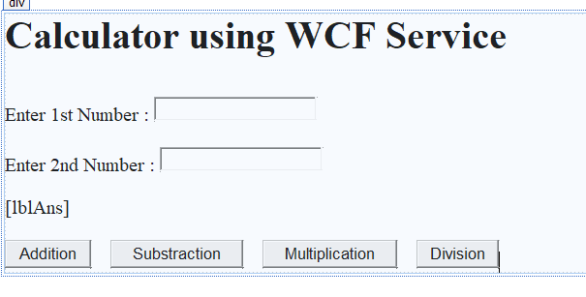

<%@ Page Language="C#" AutoEventWireup="true" CodeBehind="WF_Calculator_WCF.aspx.cs" Inherits="WcfServiceLibrary_Calculator_Client.WF_Calculator_WCF" %>

<!DOCTYPE html>

<html xmlns="http://www.w3.org/1999/xhtml">

<head runat="server">

<title></title>

</head>

<body>

<form id="form1" runat="server">

<div>

<h1>Calculator using WCF Service</h1>

<br />

Enter 1st Number :

<asp:TextBox ID="txtNum1" runat="server"></asp:TextBox>

<br />

<br />

Enter 2nd Number :

<asp:TextBox ID="txtNum2" runat="server"></asp:TextBox>

<br />

<br />

<asp:Label ID="lblAns" runat="server"></asp:Label>

<br />

<br />

<asp:Button ID="btnAdd" runat="server" CssClass="auto-style1" OnClick="btnAdd_Click" Text="Addition" />

&nbsp;&nbsp;&nbsp;

<asp:Button ID="btnSub" runat="server" CssClass="auto-style1" OnClick="btnSub_Click" Text="Substraction" />

&nbsp;&nbsp;&nbsp;

<asp:Button ID="btnMult" runat="server" CssClass="auto-style1" OnClick="btnMult_Click" Text="Multiplication" />

&nbsp;&nbsp;&nbsp;

<asp:Button ID="btnDiv" runat="server" CssClass="auto-style1" OnClick="btnDiv_Click" Text="Division" />

</div>

</form>

</body>

</html>

**WF_Calculator_WCF.aspx.cs**

using System;

using System.Collections.Generic;

using System.Linq;

using System.Web;

using System.Web.UI;

using System.Web.UI.WebControls;

namespace WcfServiceLibrary_Calculator_Client

{

public partial class WF_Calculator_WCF : System.Web.UI.Page

{

ServiceReference1.CalculatorClient proxy1 = new ServiceReference1.CalculatorClient();

protected void Page_Load(object sender, EventArgs e)

{

}

protected void btnAdd_Click(object sender, EventArgs e)

{

double n1 = Convert.ToDouble(txtNum1.Text);

double n2 = Convert.ToDouble(txtNum2.Text);

lblAns.Text ="Addition is " +proxy1.Add(n1, n2).ToString();

}

protected void btnSub_Click(object sender, EventArgs e)

{

double n1 = Convert.ToDouble(txtNum1.Text);

double n2 = Convert.ToDouble(txtNum2.Text);

lblAns.Text ="Substraction is " +proxy1.Subtract(n1, n2).ToString();

}

protected void btnMult_Click(object sender, EventArgs e)

{

double n1 = Convert.ToDouble(txtNum1.Text);

double n2 = Convert.ToDouble(txtNum2.Text);

lblAns.Text ="Multiplication is " +proxy1.Multiply(n1, n2).ToString();

}

protected void btnDiv_Click(object sender, EventArgs e)

{

double n1 = Convert.ToDouble(txtNum1.Text);

double n2 = Convert.ToDouble(txtNum2.Text);

lblAns.Text ="Division is " +proxy1.Divide(n1, n2).ToString();

}

}

}

* **OUTPUT-**

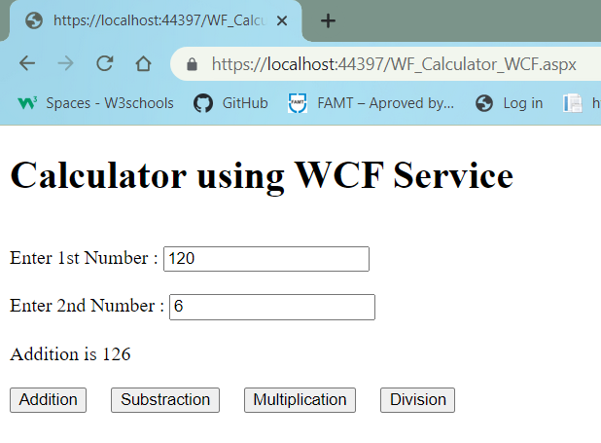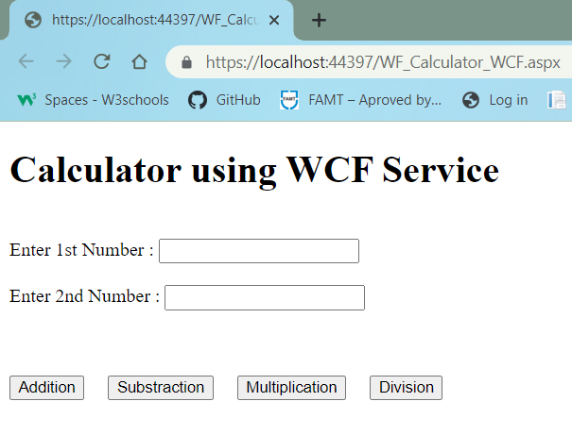

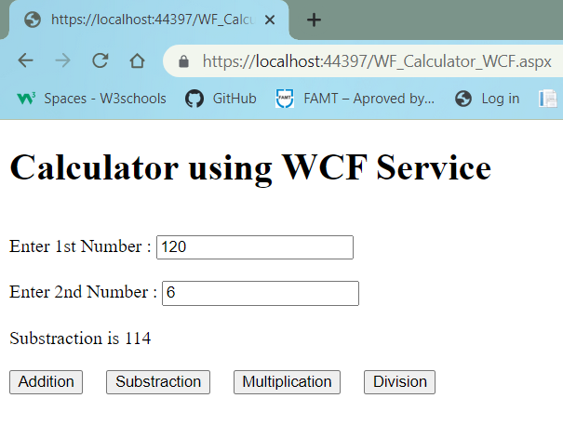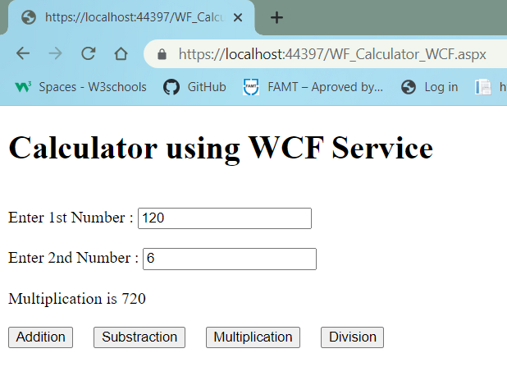

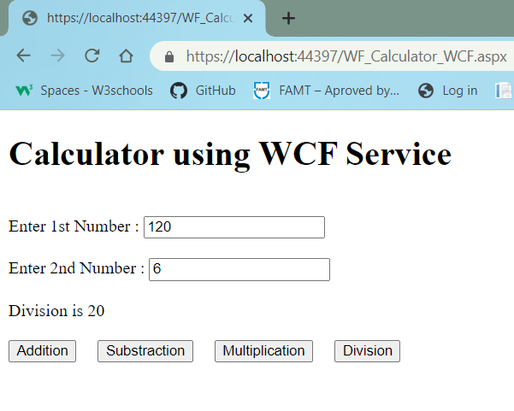

**5. Create an XML Web Service that update product details into product_info Database table. Design a Web client that consumes this service.**

**Ans:**

* **CODE –**

1. **Project 1 - XMLWebServices_ProductDB**

**WebServiceProduct.asmx.cs**

using System;

using System.Collections.Generic;

using System.Configuration;

using System.Data;

using System.Data.SqlClient;

using System.Linq;

using System.Web;

using System.Web.Services;

namespace XMLWebServices_ProductDB

{

/// <summary>

/// Summary description for WebServiceProduct

/// </summary>

[WebService(Namespace = "http://tempuri.org/")]

[WebServiceBinding(ConformsTo = WsiProfiles.BasicProfile1_1)]

[System.ComponentModel.ToolboxItem(false)]

// To allow this Web Service to be called from script, using ASP.NET AJAX, uncomment the following line.

// [System.Web.Script.Services.ScriptService]

public class WebServiceProduct : System.Web.Services.WebService

{

static string conStr = ConfigurationManager.ConnectionStrings["productConnString"].ToString();

SqlConnection con = new SqlConnection(conStr);

SqlCommand cmd = null;

[WebMethod]

public DataSet ShowData()

{

cmd = new SqlCommand("SELECT * FROM productDetails", con);

if (con.State == ConnectionState.Closed)

{

con.Open();

}

cmd.ExecuteNonQuery();

SqlDataAdapter sda = new SqlDataAdapter(cmd);

DataSet ds = new DataSet();

sda.Fill(ds);

con.Close();

return ds;

}

[WebMethod]

public int UpdateData(int pid, string pname, string pdetails, int price, int quantity)

{

cmd = new SqlCommand("UPDATE productDetails SET pname=@p_name, pdetails=@p_details,price = @prc,quantity = @qunt WHERE pid = @p_id", con);

if (con.State == ConnectionState.Closed)

{

con.Open();

}

cmd.Parameters.AddWithValue("@p_id", pid);

cmd.Parameters.AddWithValue("@p_name", pname);

cmd.Parameters.AddWithValue("@p_details", pdetails);

cmd.Parameters.AddWithValue("@qunt", quantity);

cmd.Parameters.AddWithValue("@prc", price);

int r = cmd.ExecuteNonQuery();

con.Close();

return r;

}

[WebMethod]

public int DeleteData(int pid)

{

if (con.State == ConnectionState.Closed)

{

con.Open();

}

cmd = new SqlCommand("DELETE productDetails WHERE pid=@p_id", con);

cmd.Parameters.AddWithValue("@p_id", pid);

int r = cmd.ExecuteNonQuery(); con.Close();

return r;

}

}

}

* **OUTPUT-**

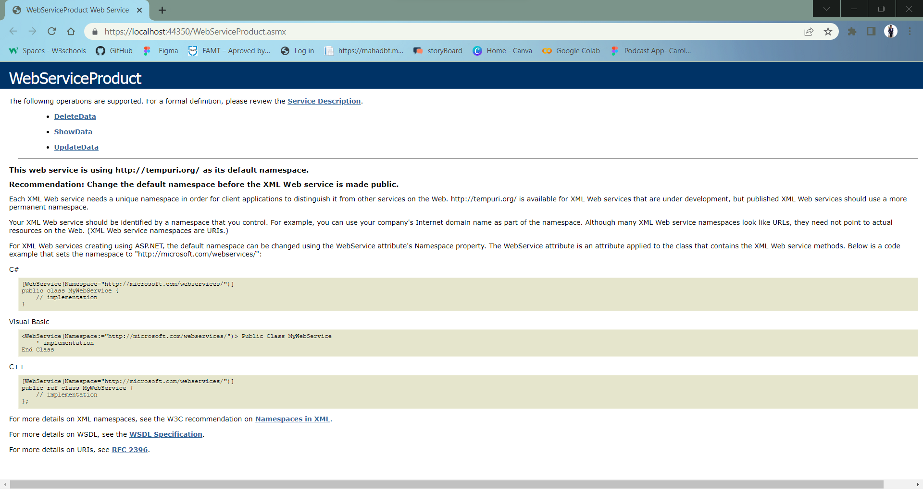

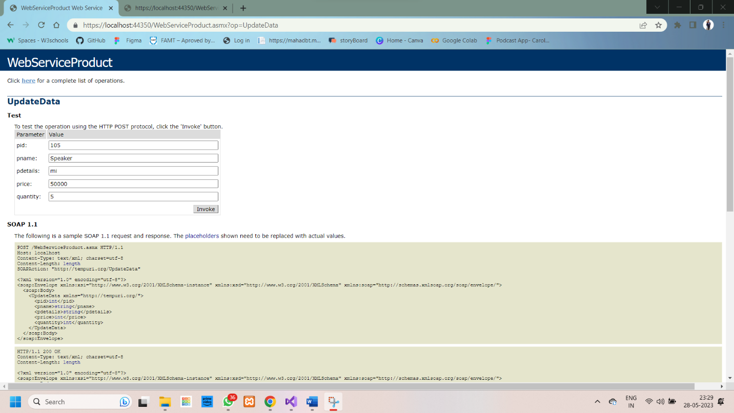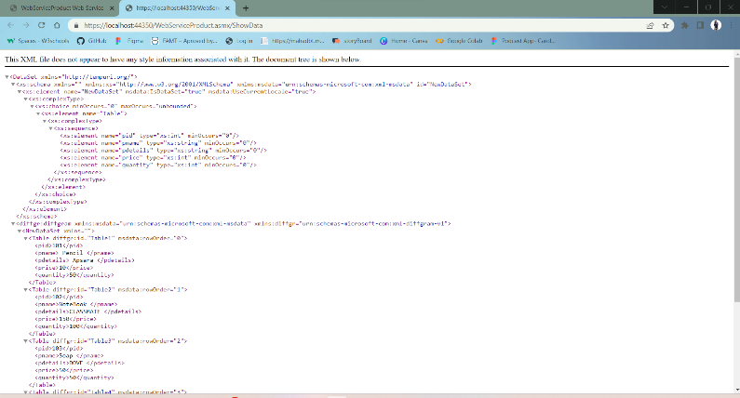

1. **Project 2- XMLWebServices_ProductDB_Client**

**WebFormProd.aspx**

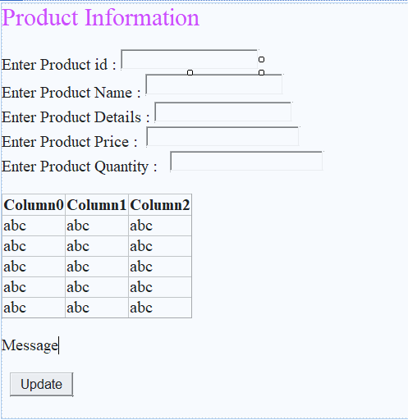

<%@ Page Language="C#" AutoEventWireup="true" CodeBehind="WebFormProd.aspx.cs" Inherits="XMLWebServices_ProductDB_Client.WebFormProd" %>

<!DOCTYPE html>

<html xmlns="http://www.w3.org/1999/xhtml">

<head runat="server">

<title></title>

</head>

<body>

<form id="form1" runat="server">

<div>

<asp:Label ID="Label1" runat="server" Text="Product Information" Font-Size="X-Large" ForeColor="#CC33FF"></asp:Label>

<br />

<br />

<asp:Label ID="Label2" runat="server" Text="Enter Product id : "></asp:Label>

<asp:TextBox ID="txtPid" runat="server" Height="19px"></asp:TextBox>

<br />

<asp:Label ID="Label3" runat="server" Text="Enter Product Name : "></asp:Label>

<asp:TextBox ID="txtPname" runat="server" style="margin-bottom: 3px" Height="20px"></asp:TextBox>

<br />

<asp:Label ID="Label4" runat="server" Text="Enter Product Details : "></asp:Label>

<asp:TextBox ID="txtDetails" runat="server"></asp:TextBox>

<br />

<asp:Label ID="Label5" runat="server" Text="Enter Product Price : "></asp:Label>

&nbsp;<asp:TextBox ID="txtPrice" runat="server" Width="179px"></asp:TextBox>

<br />

<asp:Label ID="Label6" runat="server" Text="Enter Product Quantity : "></asp:Label>

&nbsp;

<asp:TextBox ID="txtQuantity" runat="server" Width="179px"></asp:TextBox>

<br />

<br />

<asp:GridView ID="gvProductDetails" runat="server">

</asp:GridView>

<br />

<asp:Label ID="lblMessage" runat="server" Text="Message"></asp:Label>

<br />

<br />

&nbsp;

<asp:Button ID="btnUpdate" runat="server" Text="Update" OnClick="btnUpdate_Click" />

<br />

<br />

</div>

</form>

</body>

</html>

* **OUTPUT-**

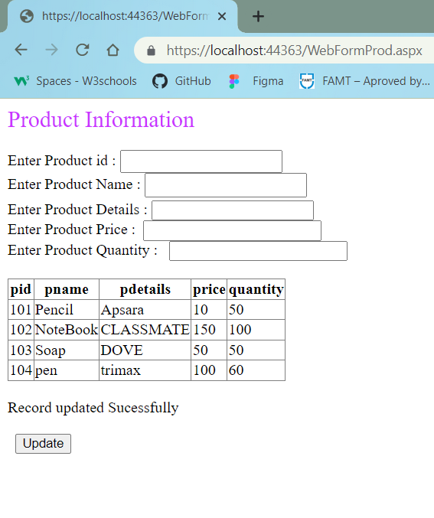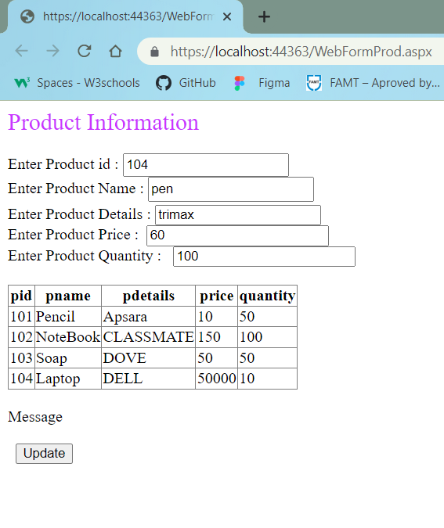

**6. Create an XML Web Service that delete product details from product_info Database table based on productID. Design a Web client that consumes this service.**

**Ans:**

* **CODE –**

**Project 1 - XMLWebServices_ProductDB**

**WebServiceProduct.asmx.cs**

using System;

using System.Collections.Generic;

using System.Configuration;

using System.Data;

using System.Data.SqlClient;

using System.Linq;

using System.Web;

using System.Web.Services;

namespace XMLWebServices_ProductDB

{

/// <summary>

/// Summary description for WebServiceProduct

/// </summary>

[WebService(Namespace = "http://tempuri.org/")]

[WebServiceBinding(ConformsTo = WsiProfiles.BasicProfile1_1)]

[System.ComponentModel.ToolboxItem(false)]

// To allow this Web Service to be called from script, using ASP.NET AJAX, uncomment the following line.

// [System.Web.Script.Services.ScriptService]

public class WebServiceProduct : System.Web.Services.WebService

{

static string conStr = ConfigurationManager.ConnectionStrings["productConnString"].ToString();

SqlConnection con = new SqlConnection(conStr);

SqlCommand cmd = null;

[WebMethod]

public DataSet ShowData()

{

cmd = new SqlCommand("SELECT * FROM productDetails", con);

if (con.State == ConnectionState.Closed)

{

con.Open();

}

cmd.ExecuteNonQuery();

SqlDataAdapter sda = new SqlDataAdapter(cmd);

DataSet ds = new DataSet();

sda.Fill(ds);

con.Close();

return ds;

}

[WebMethod]

public int UpdateData(int pid, string pname, string pdetails, int price, int quantity)

{

cmd = new SqlCommand("UPDATE productDetails SET pname=@p_name, pdetails=@p_details,price = @prc,quantity = @qunt WHERE pid = @p_id", con);

if (con.State == ConnectionState.Closed)

{

con.Open();

}

cmd.Parameters.AddWithValue("@p_id", pid);

cmd.Parameters.AddWithValue("@p_name", pname);

cmd.Parameters.AddWithValue("@p_details", pdetails);

cmd.Parameters.AddWithValue("@qunt", quantity);

cmd.Parameters.AddWithValue("@prc", price);

int r = cmd.ExecuteNonQuery();

con.Close();

return r;

}

[WebMethod]

public int DeleteData(int pid)

{

if (con.State == ConnectionState.Closed)

{

con.Open();

}

cmd = new SqlCommand("DELETE productDetails WHERE pid=@p_id", con);

cmd.Parameters.AddWithValue("@p_id", pid);

int r = cmd.ExecuteNonQuery(); con.Close();

return r;

}

}

}

* **OUTPUT-**





**Project 2 - XMLWebServices_ProductDB_Client1**

**WebForm_productDel.aspx**

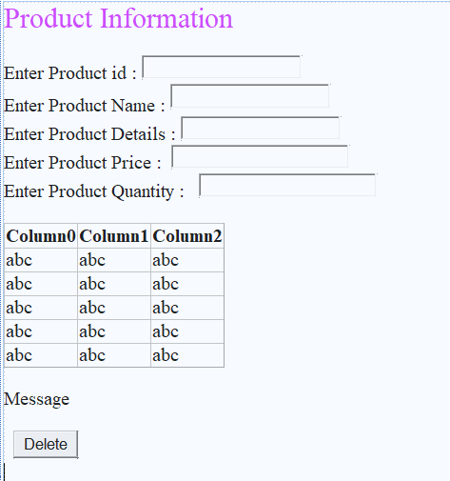

<%@ Page Language="C#" AutoEventWireup="true" CodeBehind="WebForm_productDel.aspx.cs" Inherits="XMLWebService_ProductDB_Client1.WebForm_productDel" %>

<!DOCTYPE html>

<html xmlns="http://www.w3.org/1999/xhtml">

<head runat="server">

<title></title>

</head>

<body>

<form id="form1" runat="server">

<div>

<asp:Label ID="Label1" runat="server" Text="Product Information" Font-Size="X-Large" ForeColor="#CC33FF"></asp:Label>

<br />

<br />

<asp:Label ID="Label2" runat="server" Text="Enter Product id : "></asp:Label>

<asp:TextBox ID="txtPid" runat="server" Height="19px"></asp:TextBox>

<br />

<asp:Label ID="Label3" runat="server" Text="Enter Product Name : "></asp:Label>

<asp:TextBox ID="txtPname" runat="server" style="margin-bottom: 3px" Height="20px"></asp:TextBox>

<br />

<asp:Label ID="Label4" runat="server" Text="Enter Product Details : "></asp:Label>

<asp:TextBox ID="txtDetails" runat="server"></asp:TextBox>

<br />

<asp:Label ID="Label5" runat="server" Text="Enter Product Price : "></asp:Label>

&nbsp;<asp:TextBox ID="txtPrice" runat="server" Width="179px"></asp:TextBox>

<br />

<asp:Label ID="Label6" runat="server" Text="Enter Product Quantity : "></asp:Label>

&nbsp;

<asp:TextBox ID="txtQuantity" runat="server" Width="179px"></asp:TextBox>

<br />

<br />

<asp:GridView ID="gvProductDetails" runat="server">

</asp:GridView>

<br />

<asp:Label ID="lblMessage" runat="server" Text="Message"></asp:Label>

<br />

<br />

&nbsp;

<asp:Button ID="btnDelete" runat="server" Text="Delete" OnClick="btnDelete_Click" />

<br />

<br />

</div>

</form>

</body>

</html>

**WebForm_productDel.aspx.cs**

using System;

using System.Collections.Generic;

using System.Data;

using System.Linq;

using System.Web;

using System.Web.UI;

using System.Web.UI.WebControls;

namespace XMLWebService_ProductDB_Client1

{

public partial class WebForm_productDel : System.Web.UI.Page

{

ServiceReference2.WebServiceProductSoapClient proxy1 = new ServiceReference2.WebServiceProductSoapClient();

protected void Page_Load(object sender, EventArgs e)

{

DataSet ds = proxy1.ShowData();

gvProductDetails.DataSource = ds.Tables[0];

gvProductDetails.DataBind();

}

protected void btnDelete_Click(object sender, EventArgs e)

{

int r = proxy1.DeleteData(Convert.ToInt32(txtPid.Text));

if (r > 0)

{

lblMessage.Text = "Record deleted Sucessfully";

}

else

{

lblMessage.Text = "Record Not deleted";

}

DataSet ds = proxy1.ShowData();

gvProductDetails.DataSource = ds.Tables[0];

gvProductDetails.DataBind();

}

}

}

* **OUTPUT-**

